Ideation Phase
Define the Problem Statements

Date | 08 December 2025
Team ID
Project Name | BookStore
Maximum Marks | 2 Marks

Customer Problem Statement Template:
This template is designed to define the core problems readers face while searching for books and supporting local businesses, which can guide the development of a better bookstore solution.

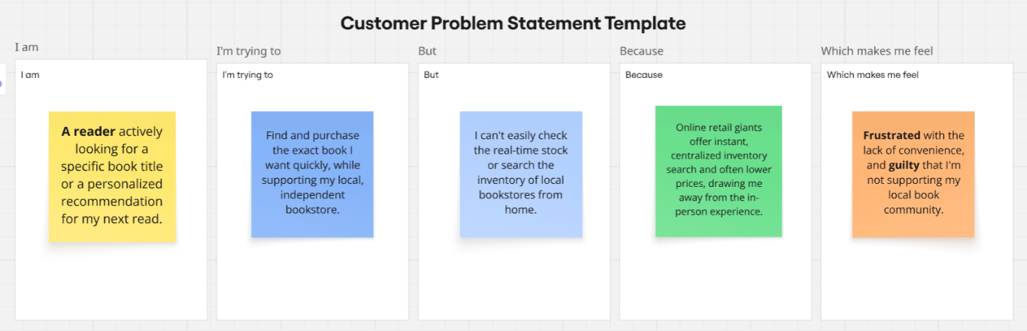
Reference: https://miro.com/templates/customer-problem-statement/

Problem Statement (PS) | I am (Customer) | I’m trying to | But | Because | Which makes me feel
PS-1 | A loyal independent bookstore customer. | Discover new, curated books and connect with a community of local readers. | The store's physical space and selection are limited compared to online platforms, and event information isn't centralized. | I miss out on local author events and unique niche titles that the bookstore might carry or recommend. | Isolated and less engaged with my local literary scene.
PS-2 | A small independent bookstore owner. | Compete effectively with online retailers and manage a sustainable, profitable inventory | Inventory management software is often expensive or clunky, making it hard to track stock, order, and sell both in-store and online efficiently. | High operational costs and outdated technology make it difficult to provide the same convenience and pricing as large online platforms. | Overwhelmed by financial and logistical pressures, and worried about the long-term viability of my passion project.

